**­**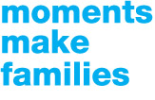





**SOS Children’s Villages Sri Lanka celebrates UN Family Day!**

Home is where the heart is. And for every child, a home is a place where there is comfort, protection and warmth, and love and care of a family. We all remember days when our dads would carry us out on their shoulders for an ice-cream, when we fought with our brothers and sisters over something, or when our mothers would be awake all night for us when we were sick. These are the precious moments that make a family. And every child deserves to experience these moments in life.

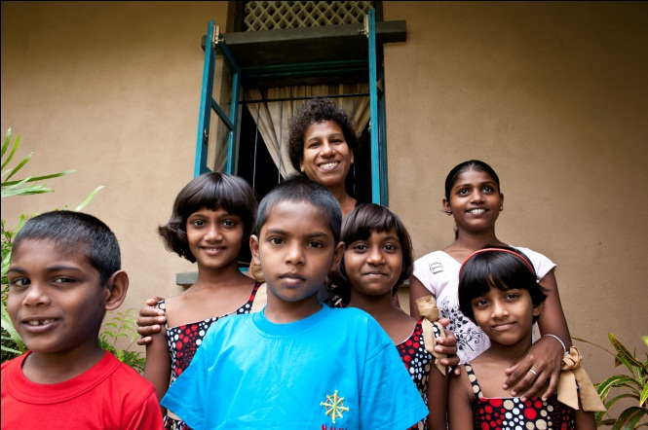

On the occasion of UN International Day of Families on May 15, the SOS Children’s Villages Sri Lanka is happy to launch its Moments Make Families (MMF) campaign. As a part of this campaign, we want all of us to share the happy memories of our childhood, the small moments spent together that seemed mundane at the time, but are the most important part of growing up.

Millions of children live without parental care. They do not have a warm bed to sleep or a mother who makes sure they are properly fed. At SOS Children’s Villages we believe that children can only develop to their full potential if they have a supportive and protective family environment. We work to make this a reality. In the family-based care of SOS Children’s Villages children live in a home with their mother and siblings and are part of a community. Like us, they experience the family moments together. They are safe and know that at the end of the day, they have a home to go to.

SOS Children’s Villages firmly believes that home is a place where children feel valued, safe, listened to and understood – where there is someone they can count on and who can help them navigate the world till they become independent. As a part of our campaign we have planned a host of activities for this year. These include a Facebook campaign, Electronic Direct Marketing promotions (EDM) and other PR activities.

You can be a part of this campaign by sharing your own childhood experiences and family moments and by spreading the word around on the importance of families for children in need. So here’s wishing you all a very happy International Families Day, with our promise to endeavor to make this day special for more and more children around the world.

------------------------------------------------------------------------------------------------------------------------

**About SOS Children's Villages**

SOS Children's Villages is an independent, non-governmental, social development organisation that provides family-based care for children in 133 countries and territories and that advocates the concerns, rights and needs of children. Approximately 63,000 children and young people live in 518 SOS Children's Villages and 392 SOS Youth Facilities around the world.

At SOS Children’s Villages we believe that children can only develop to their full potential if they have a supportive and protective family environment. We work to make this a reality. The family is part of a community that functions as a support system. Biological siblings are not separated if possible and if this is in the children's best interests. The model of the "classic" SOS Children's Village has been and will continue to be modified and adapted to local conditions and requirements.   
  
In Sri Lanka, more than 2233 children and young people attend the SOS Hermann Gmeiner School, SOS Kindergartens and the SOS Vocational Training Centre. Moreover, SOS Children's Villages provides families with material, psychological and social support. Approximately 2972 people benefit from these family support services; including the use of the SOS Medical Centres. In times of crisis and disaster, SOS Children's Villages helps through emergency relief programmes.

Founded in 1949, SOS Children’s Villages aim to be the leading voice for all children whose parents cannot care for them or who have lost their parents.